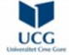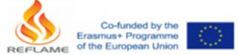
Reforming Foreign Languages in Academia in Montenegro (Re-FLAME) – CBHE 609778
STEERING COMMITTEE MEETING
28 January 2021
Date: 28 January 2021
Time: 10:00 - 11:30
Attendees:
Prof. dr Igor Lakić, the project coordinator
Doc. dr Olena Lilova, the project manager from the UniMED
Doc. dr Dragica Žugić, the project manager from the UDG
Ana Matijević, the project manager from the University of Zagreb
Prof. dr Elżbieta Gajek, the project manager from the University of Warsaw Prof. dr Borbala Samu, the member of the project team from the University for Foreigners of Perugia
Doc. dr Deja Piletić, the member of the UoM project team and the minutes taker (the 1st part of the meeting)
Dr Branka Živković, the member of the UoM project team and the minutes taker (2nd part of the meeting)
Dr Petar Božović, the member of the UoM project team
At 10.00 a.m. Igor Lakić, as the new project coordinator, initiated the steering committee ZOOM meeting.
He introduced himself to the EU partners, members of the steering committee, and stated the health reasons for delaying the date of the steering committee meeting, which, fortunately, didn’t affect the dynamics of the realisation of the project. The meeting followed the agenda that the project coordinator had prepared in advance and sent to the participants.
Agenda:
1. Discussing the activities planned for 2021
The steering committee meeting discussion including dates and the precise content of the forthcoming activities referred to the following work packages:
Reforming Foreign Languages in Academia in Montenegro (Re-FLAME): STEERING COMMITTEE MEETING, 28 January 2021
WP 4.1 Train FL teachers in blended teaching methodology
WP 4.7 Exchange FLT in HE experiences – international conference WP 4.8 Conduct a summer school
1.1. WP 4.1. Training Train FL teachers in blended teaching methodology
All the participants agreed with the suggested dates (12 April - 16 April + 23 April 2021) for the training session to be held in situ or online, depending on the COVID – 19 pandemic situation.
Trainers will be the professors from the University for Foreigners of Perugia and from the University of Zagreb.
Petar Božović explained that after almost a year of online teaching we had to cope with due to the COVID-19 pandemic, a great number of the professors of Montenegrin universities are now familiar with using the basic features of the Moodle platform, which at the kick-off meeting was proposed to be included in the content of this training session. He suggested introducing of the following topics:
∙ Up-to-date practices of blended learning
∙ Open resources and digital technologies
∙ Designing visuals, infographics etc.
∙ Formative assessment tools and the issues of credibility, plagiarism…
Elżbieta Gajek suggested conducting the needs analysis before organising the session. She proposed hybrid work as a possible topic.
Borbala Samu agreed with Elżbieta Gajek`s suggestion and observed that there are probably still some Moodle tools that professors are not familiar with. A needs analysis could also be pointed in that direction.
Everybody agreed with the above mentioned suggestions.
A survey was decided to be carried out among the professors – future trainees of the workshop while registering for the workshop.
1.2. WP 4.7 International conference
The suggested date – 17- 18 September 2021 was accepted.
The team for this WP was formed. It is composed of Igor Lakić (UoM), Petar Božović (UoM), Jelena Pralas (UDG) and Lejla Zejnilović (UniMed).
1.3. WP 4.8 Summer school
All the participants agreed with the suggested date – from 28 June to 9 July 2021. The main aims of the summer school were repeated:
∙ To test updated syllabi
∙ To test updated teaching methodology
∙ To test new textbooks.
The role of 2 EU experts (from University for Foreigners of Perugia and from University of Zagreb) during the summer school was also discussed. Igor Lakić said that the experts
Reforming Foreign Languages in Academia in Montenegro (Re-FLAME): STEERING COMMITTEE MEETING, 28 January 2021
should have a preparatory role for the summer school and observe it. They should be there as a support. Which 2 EU experts will come should be checked in the project application.
2. Discussing the ongoing development activities
2.1. Updating syllabi
The process of updating syllabi as the main aim of the WP2 and the process of reaccreditation of the programmes, which should be done in the spring semester of the academic year 2021/22 at the UoM, were also discussed. It was mentioned that there could be possible impacts of the recent changes in UoM management on this process.
2.2. Writing textbooks
Borbala Samu was interested in deadlines for the textbook reviews. It was repeated that all the first versions of textbooks should be written by the end of March, and as for the deadline for the reviewing process, Igor Lakić, the project coordinatorsuggested the end of April.
Elżbieta Gajek asked who could be engaged in the review of textbooks and whether it was possible to have a PhD student as a reviewer of the textbook if s/he could work under the supervision of one of the EU experts engaged in the project Reflame. Igor Lakić approved of this suggestion. Two of the nine planned textbooks are already in the review process.
Ana Matijević asked about a sample of the form for the review process. Elżbieta Gajek offered to help with this task. She found the official form for reviewing textbooks and she would send it to the reviewers.
The textbooks should be reviewed by two EU reviewers. If an author wants to find the third reviewer, it is up to him/her, but the process should be done within the planned period.
Minutes drafted by
Deja Piletić and Branka Živković
Disclaimer
This project has been funded with support from the European Commission. This publication [communication] reflects the views only of the author, and the Commission cannot be held responsible
for any use which may be made of the information contained therein.
Reforming Foreign Languages in Academia in Montenegro (Re-FLAME): STEERING COMMITTEE MEETING, 28 January 2021
4
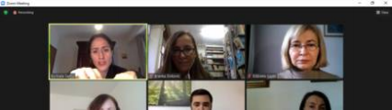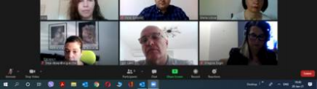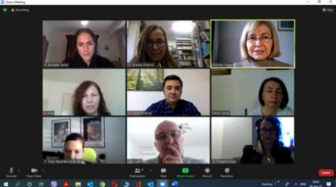
Reforming Foreign Languages in Academia in Montenegro (Re-FLAME):
STEERING COMMITTEE MEETING, 28 January 2021
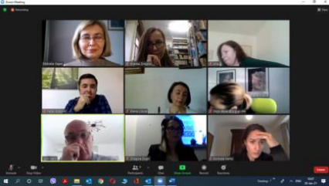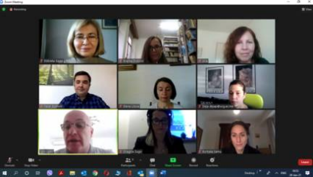
Reforming Foreign Languages in Academia in Montenegro (Re-FLAME):
STEERING COMMITTEE MEETING, 28 January 2021
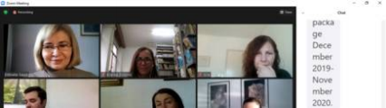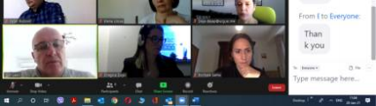
Reforming Foreign Languages in Academia in Montenegro (Re-FLAME):
STEERING COMMITTEE MEETING, 28 January 2021

